

Secondary Identification and /or Statement of Cooperation

User’s Manual for the Upper Delaware River Riverine Environmental Flow Decision Support System (REFDSS)

By Colin Talbert, Kelly Malloney, Chris Holmquist-Johnson, and Leanne Hanson

Report Series XXXX–XXXX

U.S. Department of the Interior

U.S. Geological Survey

U.S. Department of the Interior

SALLY JEWELL, Secretary

U.S. Geological Survey

Suzette M. Kimball, Acting Director

U.S. Geological Survey, Reston, Virginia: 201x  
Revised and reprinted: 201x

For more information on the USGS—the Federal source for science about the Earth,  
its natural and living resources, natural hazards, and the environment—visit   
<http://www.usgs.gov> or call 1–888–ASK–USGS

For an overview of USGS information products, including maps, imagery, and publications,  
visit <http://www.usgs.gov/pubprod>

To order this and other USGS information products, visit <http://store.usgs.gov>

Suggested citation:  
Author1, F.N., Author2, Firstname, 2001, Title of the publication: Place of publication   
(unless it is a corporate entity), Publisher, number or volume, page numbers; information   
on how to obtain if it’s not from the group above.

Any use of trade, firm, or product names is for descriptive purposes only and does not imply   
endorsement by the U.S. Government.

Although this information product, for the most part, is in the public domain, it also may contain  
copyrighted materials as noted in the text. Permission to reproduce copyrighted items must be   
secured from the copyright owner.

Contents

Introduction 1

Installation and Configuration 2

Application Installation 2

Obtaining the input data 3

The application components, inputs and outputs 5

Input Data Directory 6

Output Data Directory 6

Project Configuration File (Delaware_config.xml) 6

Scenarios/flows database (DelawareDSS_data.sqlite) 7

Setting up a new “run” of the REFDSS 7

Adding a new Oasis Run 7

Using the Delaware REFDSS 8

Adding, removing and resizing modules 9

Using views to facilitate organizing multiple modules 10

REFDSS Toolbars 11

Map Toolbar 11

Time Period Toolbar 12

Chart Toolbar 12

REFDSS Modules 14

Spatial Overview 14

Segment Map 15

Habitat Suitability Generator 16

Chart output modules 18

Change the displayed data in a single chart 18

Change individual series symbology and label 22

Format a chart 22

Hydrograph Chart 23

System Wide Metrics 24

Yearly Habitat Results 25

Summary Habitat Results 26

Flow vs Habitat Chart 28

Tabular Data Module 28

References Cited 29

Figures

**Figure 1.** Pointing the application to inputs, and output locations. 5

**Figure 2.** Module being moved and docked 10

**Figure 3.** Map toolbar 12

**Figure 4.** Chart toolbar 13

**Figure 5.** Spatial Overview Module 14

**Figure 6.** Segment Map Module 16

**Figure 7.** Habitat Suitability Generator 17

**Figure 8.** “Select Data” window. 19

**Figure 9.** “Format Series” 22

**Figure 10.** Hydrograph Chart 24

**Figure 11.** System Wide Metrics 25

**Figure 12.** Yearly Habitat Chart 26

**Figure 13.** Summary Habitat Chart with “Entire Period” option. 27

**Figure 14.** Summary Habitat Chart with “Yearly” option 27

**Figure 15.** Flow vs Habitat Chart 28

Tables

**Table 1.** REF DSS Modules. 8

**Table 2.** Delaware REF DSS Modules. 11

**User’s Manual for the Upper Delaware River Riverine Environmental Flow Decision Support System (REFDSS)**

By Colin Talbert, Kelly Malloney, Chris Holmquist-Johnson, and Leanne Hanson

# Introduction

Between 2002 and 2006 the Fort Collins Science Center (FORT) conducted field surveys, organized workshops and performed analysis of habitat for trout and shad in the Upper Delaware River Basin. This work culminated in development of decision support system software (the Delaware River DSS – DRDSS, Bovee, et al. 2007) that works in conjunction with the Delaware River Basin Commission’s OASIS model to facilitate comparison of the habitat and water delivery effects of alternative operating scenarios for the basin. The original DRDSS is available to all interested parties through the FORT web site.

Initial user feedback of the original Excel based DSS highlighted the need for a more user-friendly and powerful interface to effectively deliver the complex data and analysis encapsulated in the DSS. In order to meet this need we developed an entirely new graphical user interface (GUI) application that aims to accomplish this. The content and methodology of the new GUI interface mirrors those of the original DSS exactly with a few exceptions listed below. Please refer to the original documentation (Bovee 2007) for this information.

Significant alterations to the original DSS include:

We moved from Excel based data storage and processing to a more powerful database backend powered by SQLite. The most notable effect of this is that the previous maximum temporal extent of ten years has been replaced by a dynamic extent that can now cover the entire period of record for which we have data (1928-2000).

We incorporated interactive GIS visualization and dynamic data processing. Previous habitat maps were generated outside of the DSS in an ad hoc process that the end user could not update or investigate.

The original bathymetric data collected in 2005 was augmented with a higher resolution dataset collected in 2010. This new dataset was collected in order to model dwarf wedge mussel (DWM).

Result charts are now substantially more interactive, dynamic, and accessible which allows users to more easily focus in on their particular topics of interest as well as drill down to the source data used to calculate the given result.

# Installation and Configuration

## Application Installation

The Delaware River REFDSS application is installed using an installer available from <https://www.sciencebase.gov/catalog/folder/51d71be2e4b055e0afd5bccc>. Because of the heavy computational demands inherent in the methodology a 64 bit computer is required. Most newer computers are 64 bit but there are still 32 bit systems in use. Installation requires administrative privileges. To install simply double click the downloaded installer and follow the steps described in the installation wizard. You will also need to have at least 20 GB of hard drive storage space available on the computer to store the inputs and derived data required by the application. This data storage space can be located on an external or network drive as well.

## Obtaining the input data

The DSS requires a particular set of source data including:

1. Delaware_config.xml: A file used to store application and run specific settings. For example species and life stage parameters.
2. DelawareDSS_data.sqlite: A database containing daily scenario flows, storage levels, etc. as well as summaries of the modeled species habitat areas at various flows.
3. Inputs\Overview: A folder containing a series of geospatial layers used to display the study area overview map component.
4. Inputs\Segments: A folder containing the bathymetric covariates used to derive the habitat suitability maps as well as background imagery of the study segments.
5. Outputs\Segments: A folder containing the derived habitat suitability maps created by the application.

Because of the size of the above data the installer does not also install the required data. There are two ways to obtain this data. The first is to let the application download the data from ScienceBase as needed. This only works if you are connected to the internet but it has the advantage of ensuring that the critical data organization and naming is preserved. When you first start the application it will check that the data is available locally, and if not will present you with the following screen. You will be asked to navigate to a folder to save the data to. This workspace can be anywhere you have write permissions to.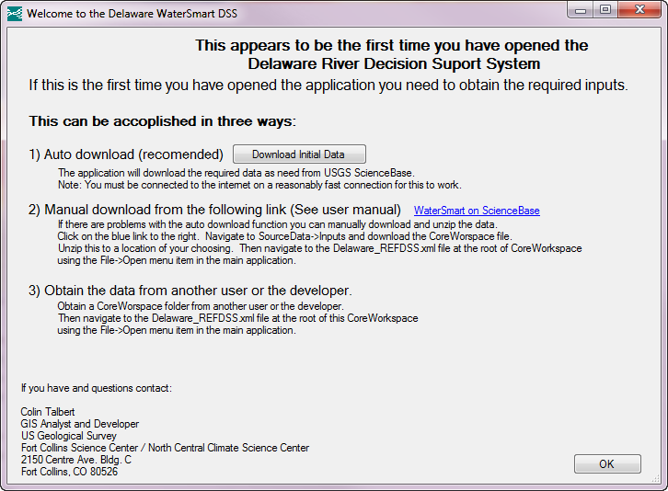

The second method of obtaining this core data is to manually download the required data directly from ScienceBase at <at in URL here> which can also be navigated to by clicking on the WaterSmart on ScienceBase link on the above form. You can find this data by downloading and unzipping the file <Add in file name on ScienceBase here once finalized> to a location of your choosing.

Click here to browse to the data location on ScienceBase.

Click here to automatically download the core data.

The third method is to obtain the data directly from another user or the developers of the application. This might be the only option for folks that don’t have a reliable or performant internet connection.

Any of the above methods for obtaining the required input data do not deliver the output geospatial habitat layers produced by the application. These outputs are only required for some of the map displays so won’t be required by all users. After downloading the inputs you will be asked whether you want to generate these layers now. If you are only interested in viewing the output charts, the inputs, maps of the inputs, or changing the HSC values and generating these maps at a later date select ‘No’. If you select ‘Yes’ the application will automatically generate all of these outputs but be aware that this data processing can take hours to complete.

## The application components, inputs and outputs

The Delaware REFDSS is a complex application composed of several interconnected pieces. The location and configuration of these is critical to the application functioning correctly. While it is possible to rename, move, or edit any of these outside of the application this is not generally advised for the general user. Each of these components can be pointed to through the main “File” menu in the upper left of the application. These components will be described in the following section.

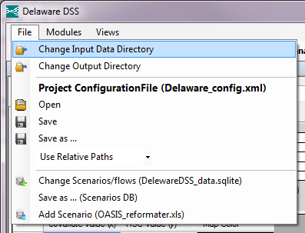

1. Pointing the application to inputs, and output locations.

### Input Data Directory

The first of these components is the “Input Data Directory”. This is a folder that contains the map inputs used by the application for display and geoprocessing. It has two subfolders one for the overview map layers and one for the other for the individual layers for each segment. All of the input files are static and do not change regardless of what subsequent processing is done. Unzipped it is about 10Gb in size so if you are going to be running the application with multiple configurations it would be most efficient to point each to the same set of inputs.

### Output Data Directory

The second component is the “Output Data Directory”. This folder contains the GIS output maps generated using the “Edit habitat suitability curves\maps” view. It contains an additional 7Gb of data so for efficiency when you first install the application these layers are not provided to you. These layers are only used for display in the individual segment map modules. The data used to drive the chart and tabular output has already been extracted and stored separately. If you are not interested in viewing the output maps you do not need to generate these maps to view the output charts. If you are interested in viewing the output GIS maps you will need to first regenerate these layers by going to the “Edit habitat suitability curves\maps” view and clicking the “Process all species” button. Switching views is described in the section of this document titled “Using views to facilitate organizing multiple modules”.

### Project Configuration File (Delaware_config.xml)

The project configuration file is a file that stores all the individual pieces of information used by the application. This includes many items that are specific to an individual user such as changes to parameters, hydroperiods, or HSCs. This file also contains the history of all changes you’ve made to charts and symbology, saved views, etc.

### Scenarios/flows database (DelawareDSS_data.sqlite)

This is the database that contains all of the flow and other daily values from each scenario. Additionally it contains summary statistics extracted from the habitat map output generated by the application.

### Setting up a new “run” of the REFDSS

Since everytime you update the HSC values and regenerate habitat maps the previous values are overwritten it is important to work on a copy of the original data when editing the HSCs and regenerating the habitat maps. Note that you do not need to do the following steps unless you will be updating the HSC values or want to maintain a copy of the default original inputs that you can go back to.

It’s important to note that there are three individual components that must be pointed to for each new “run”. For each of these feel free to name them whatever would help you track their contents. The first item you need to change is your output directory location using the second item in the File dropdown options. Next save a copy of your Project Configuration File into this directory using the Save as… item under the Project Configuration File section. Finally make a copy of your Scenario/flows database using the “Save as … (Scenarios DB)” button. To switch back to a previous run you must also change back each of these items.

### Adding a new Oasis Run

This DSS includes the three scenarios, Rev1, Rev7, and the ffmp (flexible flow management plan). The first two were included in the original DSS although the version we are using here are more current than the versions used in the original DSS. To import a new OASIS scenario you must first use the Excel based reformatter created for the original DSS and provided in the inputs folder used by this application. Instructions for its use are in cells A2-A4 on the toDSS page of the workbook. After following the update instructions, saving and closing Excel you can import the scenario by clicking the “Add Scenario (OASIS_reformatter.xls)” button from the file menu. Be aware that the code to import a new scenario has not yet been optimized so the process can take up to 15 minutes.

# Using the Delaware REFDSS

The REFDSS application is set up in a modular manner to allow flexibility in the content that is displayed at any time. Currently there are nine different components or modules in the application (Table 1). Each module consists of an independent window configured for viewing a specific type of data or summary. When using the application you can use any number of the modules at any time. Each module is independently configurable, resizable, and moveable. While each module currently open in the application is independent they do interact with each other to facilitate data analysis. For example moving the cursor on a hydrograph will update the maps to display the selected flow. If you do not want an individual module to get updated relative to other modules you can lock it by right clicking anywhere on the module and clicking “lock”. Locked modules are denoted with a “(*)” after their name in the upper left. Each module will be described in detail in proceeding sections.

1. REF DSS Modules.

|  |  |
| --- | --- |
| Module | Description |
| OverviewMap | GIS overview map showing location of each study segment |
| SegmentMap | GIS map of a single study segment |
| Habitat Suitibility Generator | Used to view and modify the habitat suitability criterial used in the DSS. Also used to regenerate the spatial habitat map output |
| Hydrograph | Chart of the daily flow, habitat, or other metrics |
| System Wide Metrics | Chart of non-habitat metrics such as drought days summarized over the period of record |
| Yearly Habitat Results | Chart of the habitat in each year |
| Summary Habitat Results | Chart of the habit across the period of record, or box plot of the yearly values. Also used to identify scenarios that deviate more than 10% from the baseline scenario |
| Flow vs Habitat Chart | Chart of the normalized habitat vs discharge functions |
| Tabular Data | View or export the raw data behind any of the charts or non-spatial inputs. |

## Adding, removing and resizing modules

New modules can be added to the application by selecting “Modules” from the upper menu and clicking on one of the module in the drop-down menu. The selected module will appear with the default size and docking (right, left, top, or bottom). To resize this module hover your cursor over one of the edges until the resize icon appears, then click and drag to the desired size. To move a module click and drag the title bar of that module to a new position. While the module is being dragged a set of docking icons will be visible as well as a ghost blue image of the modules new location. Although this type of interaction might be new to some users it soon becomes quite intuitive. Modules can be removed by clicking on the X in the upper right corner. Note that in addition to the basic docking locations within the application you can also dock modules within other modules, drag modules outside the main application window, stack multiple modules onto one another, and pin modules so they autohide when not in use.

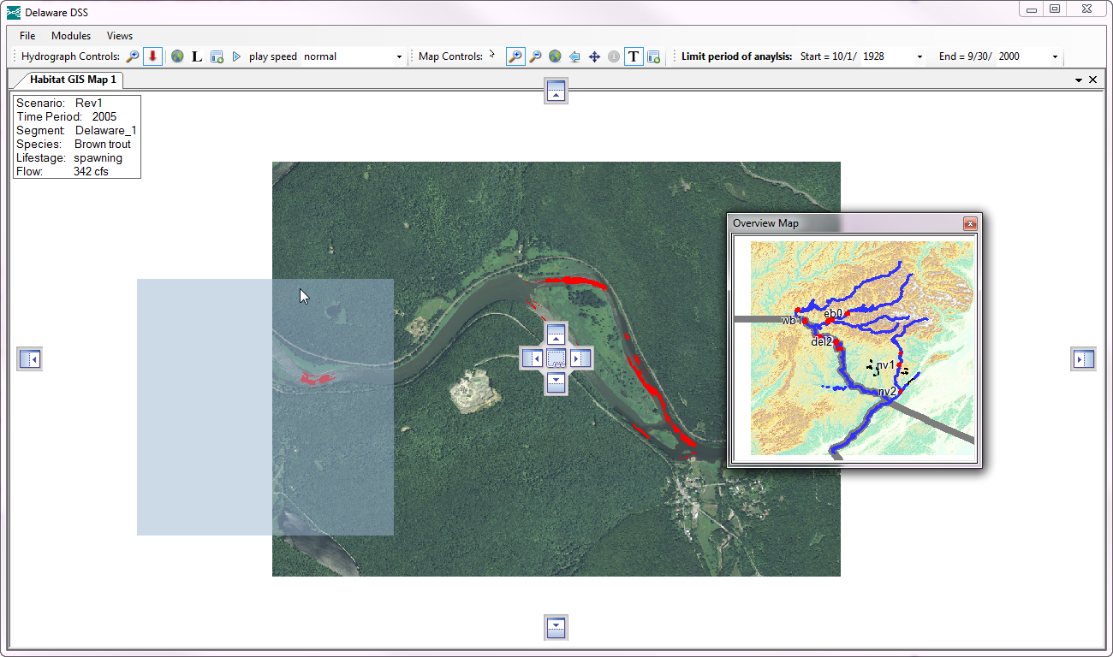

**Preview of  
 new location**

Dock or stack within another module

**Dock below**

**Dock above**

**Dock  
left**

**Dock  
right**

1. Module being moved and docked

## Using views to facilitate organizing multiple modules

Usually you will be interacting with multiple modules at once in the REFDSS. For example when editing the habitat suitability criteria it is generally helpful to have a couple segment maps displaying the inputs covariates as well as a hydrograph so that you can see how these covariates change at different flows. While it is possible to bring in and set up each of these modules individually to create this “view” the REFDSS provides the ability to easily open, switch between and save views. comes with several built-in “views” that a user can select to efficiently bring up a specific configuration of modules. To select one of these built-in views click “Views” on the top menu bar and select one of the items listed below. These built in views are listed in table 2. The built-in views that come with the application are in not intended to comprehensively cover all of the various configurations that users might need but instead provide examples of how you might want to arrange and configure modules. If a user has set up a particular view that they would like to save they can do this by clicking “Views” from the top menu bar and selecting “Save current view”. They will then be prompted to enter a name for the new view.

1. Delaware REF DSS Views.

|  |  |  |
| --- | --- | --- |
| View | Description | |
| Spatial Overview | | A segment map module for each study section as well as an overview map module |
| Brown Trout Summary | | Summary habitat result modules for each brown trout life stage |
| Shad, DWM, SF and SS Summaries | | Summary habitat result modules for remaining species |
| Main Stem Covariates | | Shows all the covariates on the main stem |
| Comparing 2005 to 2010 Covariates | | Showing an example of how the 2005 covariate inputs differ from the 2010 versions |
| Edit habitat suitability curves\maps | | Used for editing the habitat suitability curves and rerunning the geoprocessing. |
| Habitat vs Discharge | | Showing the Habitat vs Discharge module. Can be used to view any of the species |
| Brown Trout Adult Drill Down | | Demo showing how you can trace back from a summary to the raw inputs |
| Comparing 80s vs 90s West Branch Brown trout adult habitat | | Demo showing how you could compare two time periods |

# REFDSS Toolbars

Docked at the top of the REFDSS application you will see three toolbars used for interacting with various modules. One is for the two map modules, one changes the time period of used for analysis, and the last is used for the various output charts.

## Map Toolbar

The map toolbar contains various items useful for interacting with the map modules. The first four change the type of interaction\cursor the mouse has with the map. Users or any online mapping or Geographic Information Systems (GIS) will be familiar with their use. The next two are used to either zoom to the full extent or the previous extent. The last will turn on or off the maps title box.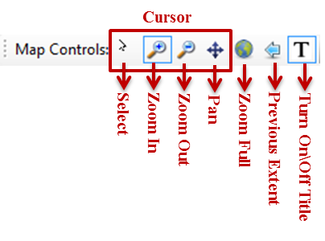

1. Map toolbar

## Time Period Toolbar

The next toolbar can be used to limit the entire period of record by selecting a start and end year. Be aware that individual modules can have specific start and end dates that are more restrictive than the global values set here. See the view titled “Comparing 80s vs 90s” for an example of this. Also note that changing the values in this toolbar will update the values used in all the current modules. By default we are using the entire period of record or 1928 through 2000.

## Chart Toolbar

The last toolbar contains items specific to the various chart modules. The first two items change the type of interaction\cursor the mouse has with charts. The “zoom in” cursor is used to display a section of the chart in greater detail. After select the “Zoom In” button click and drag over a section of a chart to make that subset of the data fill the chart area. The “Select” cursor is specialized to only work on the hydrograph chart modules. If you have a segment map displaying a map layer corresponding to one of the flows displayed in the hydrograph then clicking on a point in the hydrograph with this cursor will update the segment map to display the map data most closely corresponding to the selected flow. This can be extremely useful when trying to determine how input covariates and output habitat change across a range of flows. The final two items on the toolbar allow you to play a time lapse animation of the map display changing in response to the hydrograph values. The view named “Edit habitat suitability curves\maps” is set up to provides a demonstration of this selection and animation. Open this view and try clicking on the hydrograph on the bottom. Notice how the maps update to display layers corresponding to the selected flow. Click the “Play” button to view an animation. Click that button again to stop the animation.

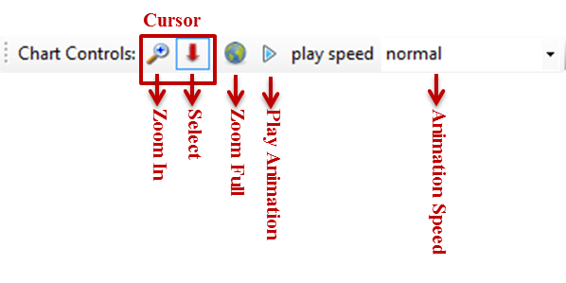

1. Chart toolbar

# REFDSS Modules

## Spatial Overview

The spatial overview module provides a means of seeing a map of the entire study area. Each of the 11 study segments are outlined in red. If you have the select cursor selected in the map toolbar you can add a new segment map module by clicking on one of the red squares in this map display.

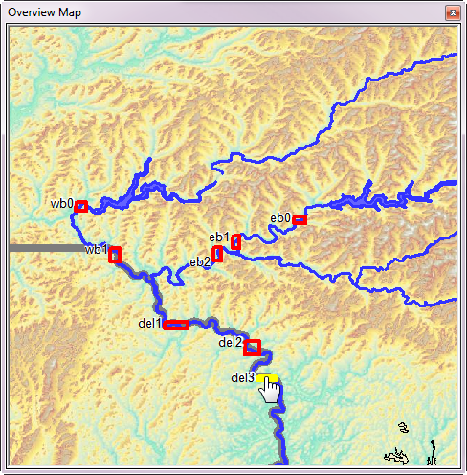

1. Spatial Overview Module

## Segment Map

The segment map module provides a means of seeing a detailed map of an individual study segment. On top of an aerial image of the area you can display one of the covariates or outputs. To change either the study segment or the overlaid map layer right click on the map or it’s title bar and a context menu will appear. Hover your mouse over scenario, segment, time period, species, lifestage, covariate or flow you are interested in seeing. The list of available items under that category will appear for selecting. To display or remove the title box click the “T” icon on the map toolbar.

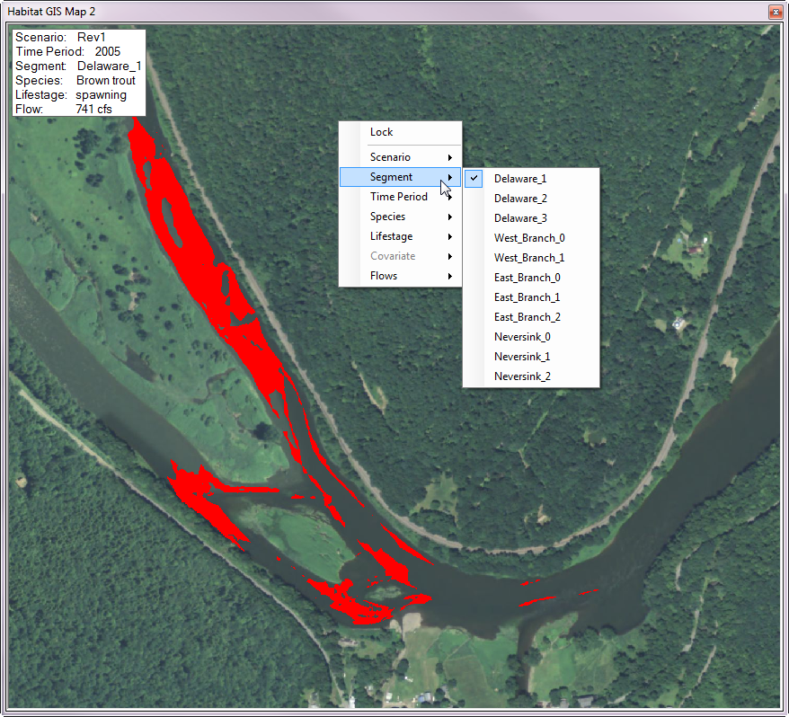

1. Segment Map Module

## Habitat Suitability Generator

The habitat suitability generator module provides functionality to view and change the habitat suitability criteria (HSC) used to generate habitat maps for the DSS. Additionally it allows you to view and edit the equation used to generate the habitat maps and finally it contains functions to regenerate the map outputs when changes to the HSCs or equations have been made.

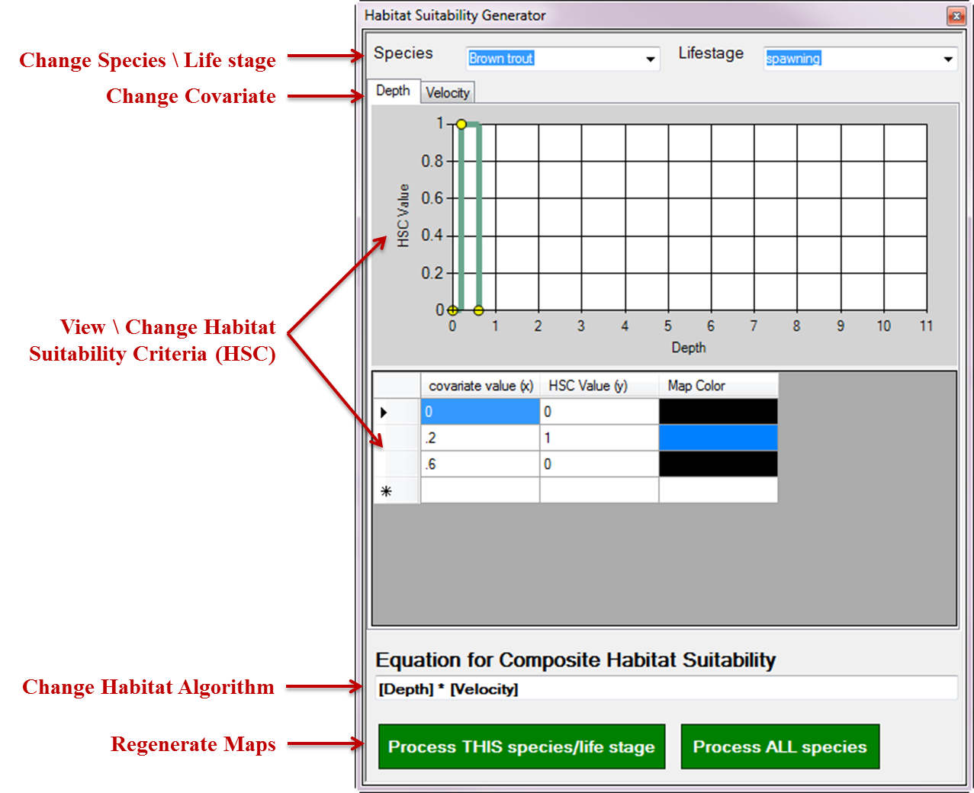

1. Habitat Suitability Generator

In the center of this module there is a chart that displays an HSC curve for a single species, life stage and covariate. Beneath that curve is a list of the x, y values that it is comprised of. Edits to the curve can be made by either changing the values in the table below or clicking and dragging on one of the yellow dots on the curve chart. To change the species or life stage HSC displayed in the central portion of the module select them from the dropdown boxes at the top of the module. To switch between different input covariates (i.e. depth and velocity) select the tabs immediately above the chart.

If you have a segment map module visible you will be able to see how changes to the HSC affect the spatial habitat inputs. The third column in the table below the HSC chart shows the color that will appear on the map for that bin of the HSC. Double click on the color box to change this color. Black indicates areas that will be displayed as transparent. To try this open the “Edit habitat suitability curves\maps” view. You will notice that the two segment map modules displaying depth and velocity are displaying the default symbology for those layers. Change one of the HSC values in either the chart or table to get the segment map modules to update their display.

Once all changes to the HSCs have been made the user can update the equation used in the text box at the bottom of the form. Standard mathematical symbols can be used with the covariates specified with square brackets. For example the default algorithm for brown trout spawning is “[Depth] * [Velocity]” This means that the Depth grid (or map) is going to be reclassified according to the depth HSC and then multiplied by the Velocity grid reclassified according to the velocity HSC. If you wanted to change this algorithm to be the square root of depth squared * velocity squared you would enter “([Depth]^2 * [Velocity]^2)^0.5)”

Once the equations have been set you are ready to regenerate all of the outputs. To process the outputs for a single species/life stage click the “Process THIS species/life stage” button. The processing time for a single species depends on the computers speed and memory but should be around 20 min. To reprocess all of the species and life stages click the “Process ALL species” button. The processing time for all species takes considerably longer, somewhere around four hours.

# Chart output modules

These modules are used to display various outputs in a graphical or chart based form. They share several features that will be described in this section. First each has a context menu that can be brought up by right clicking in the module or its title bar. The context menu lists several useful options including printing the chart, saving a jpeg image of the chart, or copying it to the clipboard (for use in another application for example).

## Change the displayed data in a single chart

The context menu contains an option titled “Select Data” which allows you to change the data that the chart is displaying. Selecting this brings up an interface that allows you to select multiple items for display. This interface will be slightly different for each of the output chart modules depending on what they are configured to display. For example the scenario and baseline selection box will not be visible in a “Flow vs Habitat Chart” because these the flow vs. habitat charts are the same for all scenarios. Note that when multiple items are selected in each of the categories the total number of items displayed in the resulting chart are multiplicative. For example if you select 3 scenarios, 2 time periods, 4 river/segments, and 6 species/life stages you will end up with 144 elements in the output chart. This will quickly lead to indecipherable charts so it is best to limit the cumulative number of elements in any given chart and instead have multiple charts each with a specific item of interest.

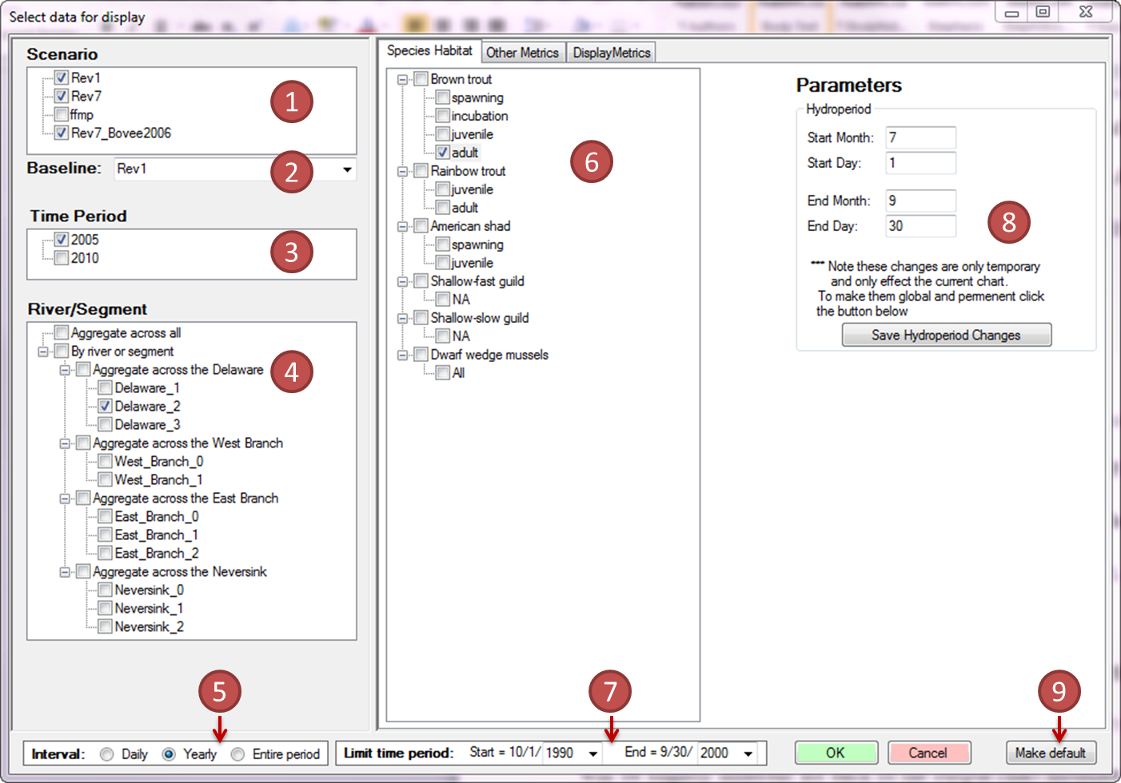

1. “Select Data” window.

While there are numerous elements on the form their use is relatively straight forward. You can select one or more scenarios being considered in the upper left box labeled 1 in the figure above. Beneath the Scenario selection box at circle two is a dropdown box for selecting a baseline scenario. This selects one of the scenarios to use as a baseline comparison against the remaining ones. Percent change between each scenario and the one selected here will be reported and scenarios that have a 10% or greater increase will be flagged green while a 10% or greater decrease will be flagged red. This option only applied to the “Summary Habitat Chart” and the “Tabular Data” modules.

Unlike the original 2006 DSS we have a second series of environmental covariates collected in 2010. While not drastically different than the original 2006 version they were collected at a finer resolution and include the metrics Froude, sheer stress, and sheer velocity that were not in the original set of covariates. These data were only collected for the three main stem study segments, Del0, Del1, and Del2. Also the dwarf wedge mussel (DWM) HSCs use these additional covariates and thus are only being calculated for these segments. To switch between or compare the output from these two time periods select one or more from item 3 in figure 7.

The “River/Segment” selector (item 4) allows you to select which river or study segments will be displayed. At the lowest level results for individual segments can be displayed by checking the innermost nodes. If you would like to summarize a metric for an individual river you can select any of the “Aggregate across the …” nodes immediately above the individual segment nodes. Checking the “Aggregate across all” node will provide a single summary for the entire system. The method used to summarize across a river is described on page 31 of Bovee et al 2007. “Aggregate across all” summarization is the sum of the totals for each river reach summarization. Note that the check box titled “By river or segment” is an organizational placeholder and has no effect. Also note that certain charts do not support the aggregation of data. And finally be aware that the data summarization is done dynamically for all charts as they are being updated. When using the aggregate across all or the aggregate across river options display time might take some time, especially when using the full time period of record.

The interval selection box (item 5) is used to select a method of temporal aggregation of the results. “Daily” shows the raw data and is only used in the “Hydrograph” chart and the “Tabular Data” module. The “Yearly” option will calculate a given metric for each individual year. This allows you to observe temporal variability and changes over time more easily than daily data. This option is currently only used in the “Summary Habitat Results” chart and the “Tabular Data” module, although the “Yearly Habitat Results” uses it by default as well. The final option is “Entire period” which does not aggregate results by year but summarizes them as a single list. This option is the same as that used in the original Bovee 2007 DSS.

The “Species Habitat” selection box (item 6) allows you to select which species/life stages will be displayed. Note that the top level check boxes next to the species names do not have an effect as we have no way of summarizing all of the individual life stage data for species. With a life stage selected (i.e. clicked on) the hydroperiod parameters (item 8) are enabled and display the values used for that life stage. You can change the values used in the provided check box. Note that the changes to hydroperiod are only temporary and only apply to the single chart linked to this form. To make your changes permanent and global click the “Save Hydroperiod Changes” button.

If you would like to limit the time period for this particular chart change the start and end year in the “Limit time period” box. Note that changes in this form only apply to the chart being updated and will not affect other charts. To globally change the period of record use the comparable boxes on the top menu bar of the application.

If there are a different specific set of elements that you would like to see every time you bring in a new chart of this type you can click the “Make default” button (item 9). The “Other Metrics” tab (item 10) allows you to display non-habitat metrics such as storage volumes, releases, diversions, targets, spills, etc. It is only available for the “Hydrograph” chart or the “Tabular data” module. The “Display Metrics” tab (item 11) allows you to change the temporal aggregation parameter used to calculate the yearly and entire period summaries. The default value “Average of bottom 25% of habitat” is equivalent to what was used in the original DSS. In addition “Minimum single habitat” and “Average all Habitat” are available.

## Change individual series symbology and label

While default symbology for individual chart series will suffice for many cases you will often need to adjust the color, line width, line type, and displayed title for improved readability. To do this click on the series symbol in the chart legend to bring up a simple interface for changing these attributes. Note that these changes are saved globally so the next time you bring this series into a new chart it will have this label and symbology.

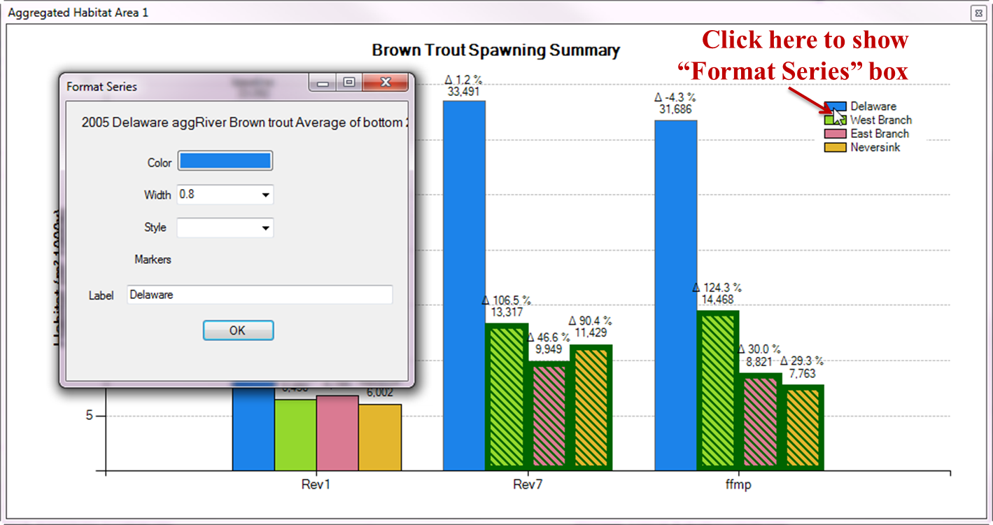

1. “Format Series”

## Format a chart

Reasonable defaults have been provided for the various elements that determine how a chart will look. In many cases you will want to change these to improve the display or labeling. For example if you change the data to display a different life stage the title of the chart will not automatically update. By right clicking on a chart and selecting “Format Chart” a window will appear that allows you to change various formatting elements in the chart. Changeable elements include: title text, title font, title location, axes labels, axes font, axes scale, tick marks, and grid lines. Much like the select data window, if you make changes that you would like to see every time you open this type of chart click the “Make default” button to use the current formatting on all charts of this type in the future.

## Hydrograph Chart

To display a line graph of daily flow (Q), habitat, or any of the other metrics use the “Hydrograph” module. Flow series are use the left or primary Y axis. Other daily series use the right or secondary Y axis. Note that when displaying multiple disparate metrics on the second right axis it might not be possible to have them line up reasonably with a single scale. For example it is not possible to have a chart that meaningfully shows drought conditions (values 0-3) at the same time as showing Beaverkill smoothed Q (values 0-17,000). If you hover your mouse pointer over any line a small box will pop up showing the exact date and value at that point.

You can zoom in on a section of the chart to get a better view of the fine temporal resolution. To do this click the cursor zoom icon on the chart controls toolbar and click and drag a box around a section of the chart you would like to zoom to. When zoomed in you can scroll using the scroll bar at the bottom or left of the chart. To zoom back out either click the global extent icon on the chart toolbar or one of the small circles at the left end of the X axis scroll bar or the top of the Y axis scrollbar.

When displaying habitat areas on the hydrograph chart only the time periods corresponding to the hydroperiod for that life stage will show data. These temporal extents will be highlighted with colored boxes on the chart. If a segment map is currently being displayed that is set to the same scenario as the flow being displayed in the hydrograph chart the displayed map will sync with the flow under the current cursor position. To try this, open the “Edit habitat suitability curves\maps” view. Click on the select cursor (downward red arrow) on the chart controls toolbar. And click on the hydrograph at the bottom of the screen. All three upper maps will update to display the corresponding map that most closely matches the selected flow. You can also view an animation of these flows over time by clicking the “play” button on the chart controls toolbar.

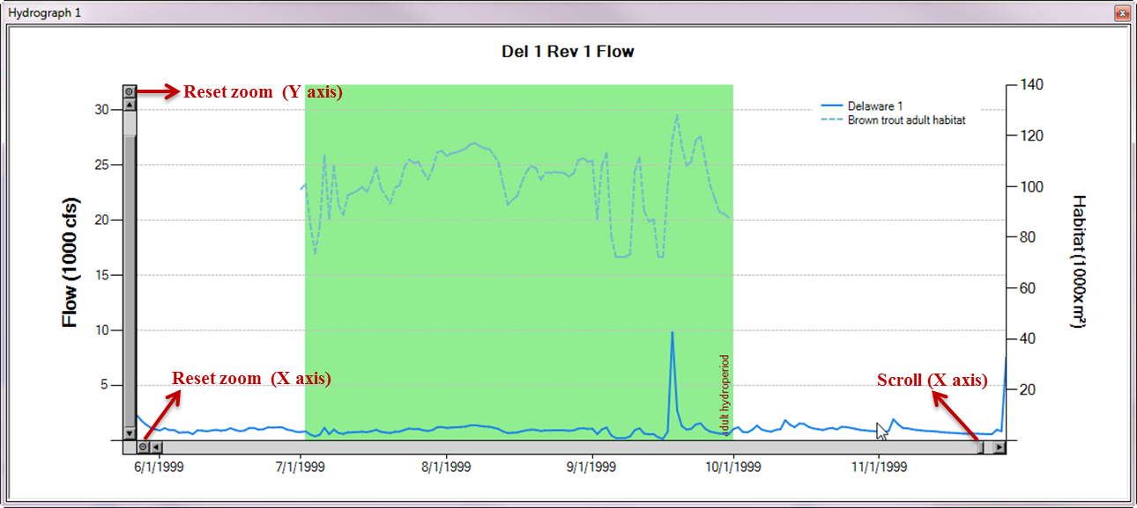

1. Hydrograph Chart

## System Wide Metrics

The “System Wide Metrics” chart is used to view a summary of several non-habitat metrics. Currently these are: “Montague shortage magnitude Major % of Minimum delivery”, “NYC shortage magnitude Major % of Minimum delivery”, “New Jersey shortage magnitude Major % of Minimum delivery”, and “Drought days”. Unlike the other charts switching between these and changing the parameters used for them is through a context menu that is shown when you right click on the chart. The “Metric” item in this menu will allow you to select one of the four metrics. The “Parameters” item will allow you to change one of the parameters used to calculate the value.

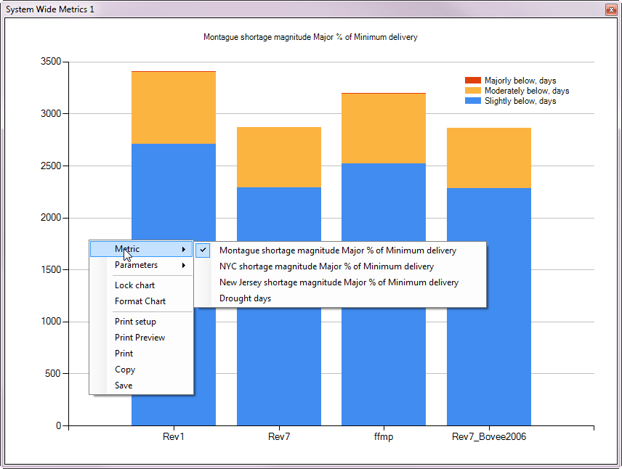

1. System Wide Metrics

## Yearly Habitat Results

The “Yearly Habitat Results” chart is used to view all the habitat results summarized by year. This is similar to viewing the daily habitat for a species in a hydrograph chart but instead of a line graph it has a single bar for each year. Zooming and panning a “Yearly Habitat Results” chart will simultaneously sync the extent of any hydrographs that are currently open. This allows you to pan through the period of record simultaneously to determine the single events that led to the yearly observations. This interaction can be seen in the bottom two charts in the “Brown Trout Adult Drill Down” view.

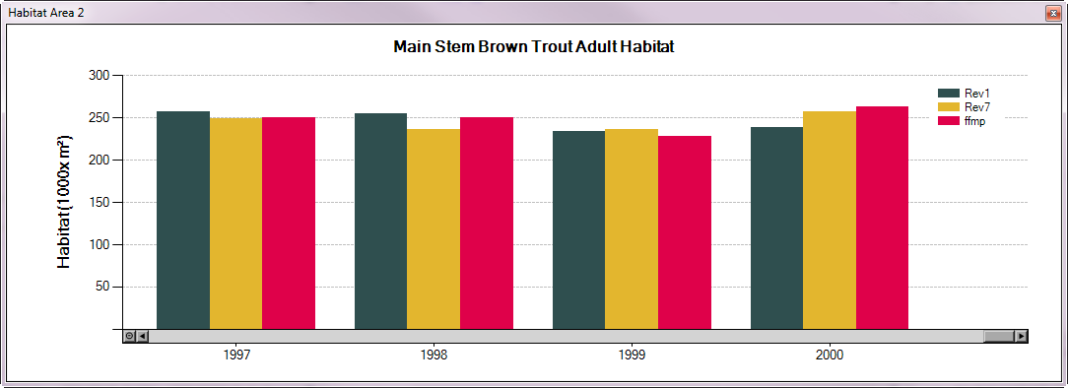

1. Yearly Habitat Chart

## Summary Habitat Results

The “Summary Habitat Results” chart is the final level of habitat data summarization. It presents a chart with a single value, or box plot of the variability of in the yearly values, for a given species / life stage. Additionally the Summary Habitat Results chart allows a user to select a baseline scenario to compare the other scenarios against. The percent change between this baseline and each chart is displayed on the chart above each point. If the output for one of the other scenarios increases by more than 10 percent its bar is highlighted in green and if it decreases by more than 10 percent its bar is highlighted in red.

One important item to note about the Summary Habitat Results chart is that it can display output in two distinct ways. If you select “Entire Period” as the interval in the select data screen a single value will be displayed for each scenario. This value takes the daily values for the entire period of record and applies the selected display metric (by default “Average of bottom 25% of habitat”) to the full list at once. This is equivalent to how these values were calculated in the original DSS. If instead you select an interval of “Yearly” then the display metric is applied to each year’s data individually and the results are displayed with a box plot on the chart. The points displayed in the box plot are min, max, 25th and 75th percent, mean, and median. A larger spread indicates more variability between years.

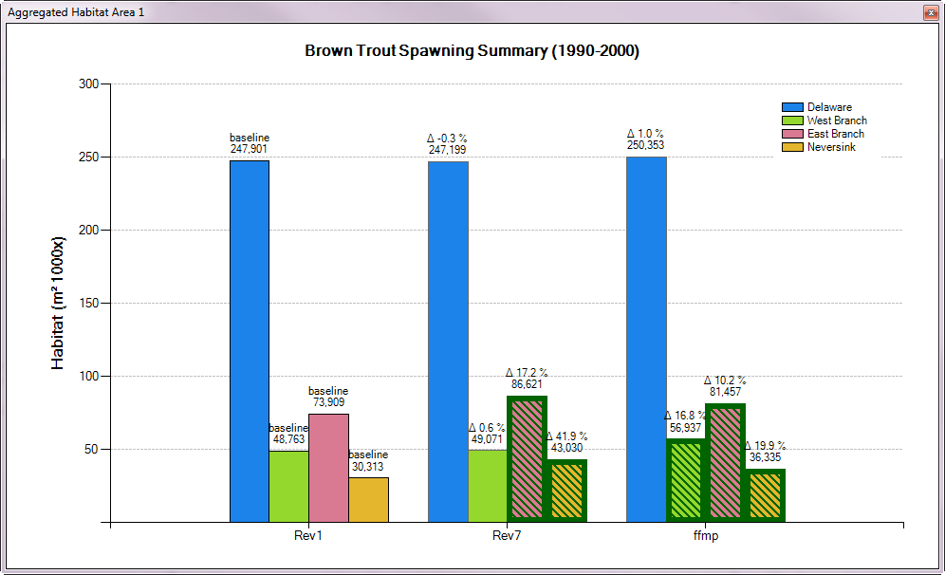

1. Summary Habitat Chart with “Entire Period” option.

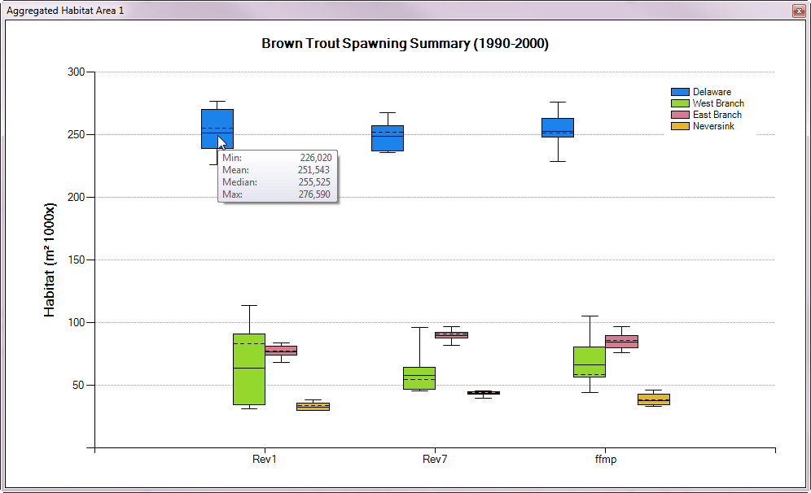

1. Summary Habitat Chart with “Yearly” option

## Flow vs Habitat Chart

The “Flow vs Habitat Chart” presents a means of visualizing the habitat versus discharge functions generated from our output maps. The techniques used to generate these charts is described in Bovee et al. 2007 on page 37.

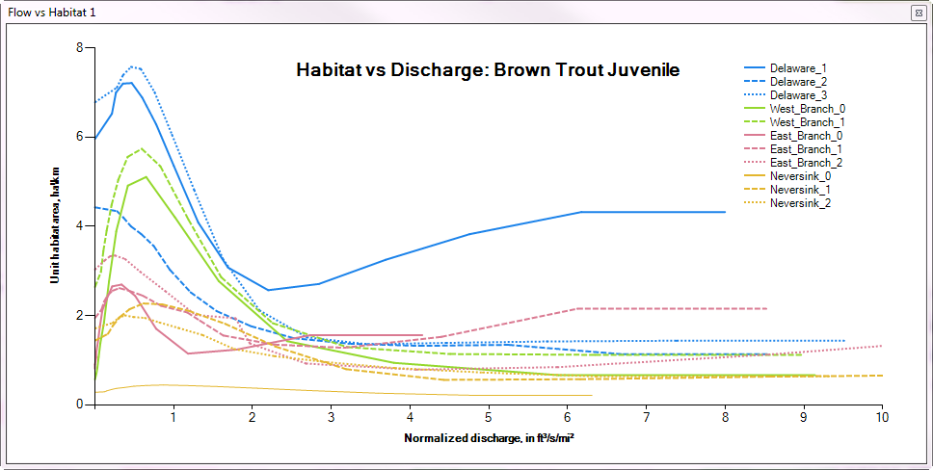

1. Flow vs Habitat Chart

## Tabular Data Module

Each of the charts described above relies on a series of values extracted from a simple SQLite database using complex SQL queries. As such manually getting to the raw inputs for any given chart will be difficult for the novice DSS user. The Tabular Data Module facilitates direct access to this raw data. Selecting what data it displays is done in much the same manner as for most of the charts with the same “Select Data” screen opened from the right-click context menu on the table. Additionally many of the charts will allow you to view the raw data values that they are displaying by selecting the “View Tabular Data” option from the context menu.

The context menu for the tabular data module also contains options for copying the currently selected data or all the data to the clipboard. Once on the clipboard, the data can then be directly pasted into Excel. Additionally there is an option to save all the current data to an external text file in coma separated format (CSV). This saved file can then be brought directly into most other data analysis and visualization programs including R, Python, Excel, or Access.

The “Tabular Data Module” uses the same red and green color coding of deviations from the baseline as in the Summary Habitat Results chart. This is only displaying when “Yearly” or “Entire period of record” is selected as the interval.

# References Cited

Bovee, K.D., T.J. Waddle, J. Bartholow, and L. Burris. 2007. A decision support framework for water management in the upper Delaware River: U.S. Geological Survey USGS Open-File Report 2007-1172. 122 p.

Appendix A – Credit for Open-Source Components Used

The development of the Delaware REFDSS would not have been possible without the use of several open-source and free projects that contributed tremendously.

* GIS map display is provided by the MapWinGIS ActiveX Control Project which is part of the MapWindow GIS Open Source Project (<http://www.mapwindow.org/>)
* The user configurable docking windows are from the DockPanel suite available at http://dockpanelsuite.sourceforge.net/
* The database backend use SQLite with the dot.net bindings. (<http://www.sqlite.org/about.html>)
* Unzipping functionality uses the DotNetZip Library (<http://dotnetzip.codeplex.com/>)
* Charting functionality was through the built in Microsoft Charting Library